create database labpracticle1;

use labpracticle;

**-- 1)Create table product**

create table product(p_id int primary key,p_name varchar(20) not null,p_price int not null); (-- with constraints)



**--2)create table customer**

create table customer(c_id int primary key,country varchar(20),age int,aadhar_card_no int not null unique,c_name varchar(20)); -- add constraints

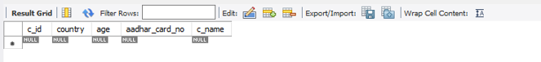

**--3) create table sales**

create table sales(s_id int primary key,c_id int,p_id int,quantity int,

foreign key(p_id) references product(p_id),

foreign key(c_id) references customer(c_id));



**-- Inset value in product table**

insert into product values (1,"maggie",220);

insert into product values (2,"biscuit",160);

insert into product values (3,"coffee",180);

insert into product values (4,"Sugar",150);

insert into product values (5,"rice",200);

insert into product values (6,"Aata",40);

insert into product values (7,"coffee",2500);

insert into product values (8,"Tea",140);

insert into product values (9,"Cold Drink",300);

**-- now inserting values in customer table**

insert into customer values (401,"Ajay","India",20,123222332);

insert into customer values (402,"snehal","Australia",20,123122332);

insert into customer values (403,"saylee","Japan",35,123322332);

insert into customer values (404,"komal","UK",20,22321332);

insert into customer values (405,"diksha","Japan",47,623222332);

insert into customer values (406,"akshada","India",20,423262332);

insert into customer values (407,"amisha","India",20,423222332);

insert into customer values (410,"vishakha","Sri Lanka",45,413222376);

insert into customer values (409,"bhagyashree","Sri Lanka",45,413222356);

**-- now inserting values in sales table**

insert into sales values(101,401,2,1);

insert into sales values(102,401,1,5);

insert into sales values(103,403,2,1);

insert into sales values(104,402,5,1);

insert into sales values(105,406,2,1);

insert into sales values(106,403,6,1);

insert into sales values(107,407,3,2);

insert into sales values(108,402,4,8);

insert into sales values(109,405,5,4);

insert into sales values(110,403,9,1);

**-- 4) show the product with maximum price**

select max(p_price) from product;

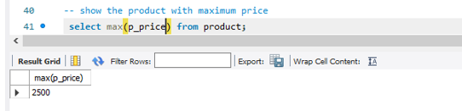

**-- 5) show the sales with minimum quantity**

select min(quantity) from sales;

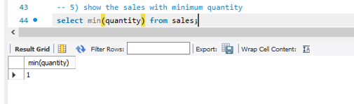

**-- 6) show all the product whose name start with A**

select * from product where p_name like "A%";

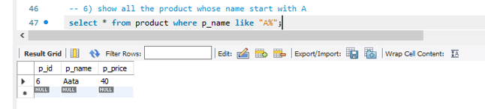

**-- 7)show all the customer who are from "Australia"**

select * from customer where country like "Australia";

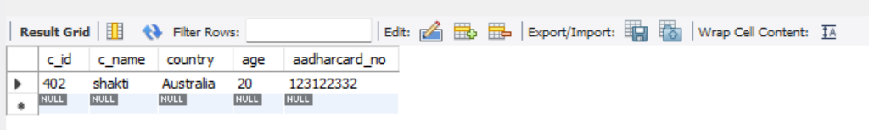

**-- 8)show all the customers who are from "Japan" and have age greater than 30**

select * from customer where country="Japan" and age>30;

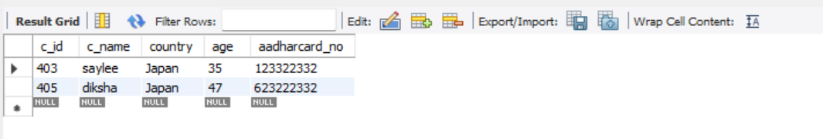

**-- 9)show all the product with price range 200 to 500 rupees**

select * from product where p_price between 200 and 500;

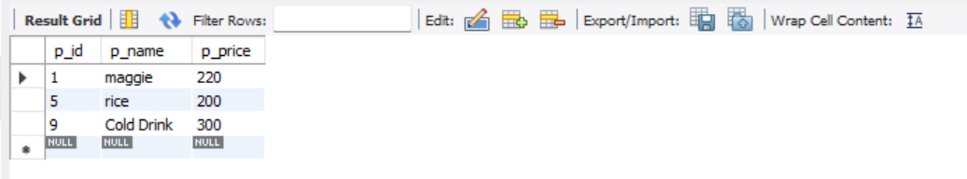

**-- 10)show all the sales product where you will list the price and also the total amount paid per sales**

SELECT s.s_id, p.p_name, p.p_price, s.quantity,s.quantity*p.p_price as total_amt

FROM sales as s INNER JOIN product as p

ON s.p_id = p.p_id;

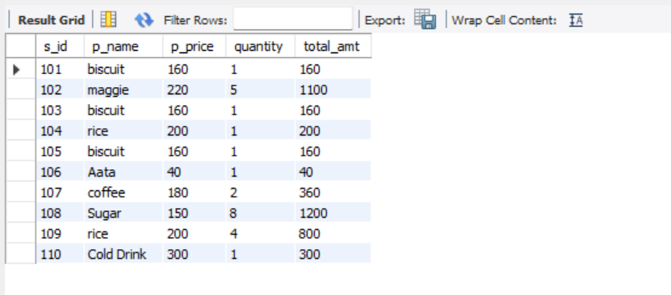

**-- 11)show all the product which are having price less than 200 and have the name starting with s**

select * from product where p_price<200 and p_name like "s%";

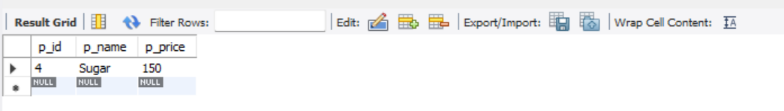

**-- 12)change the name of customer 402 to shakti**

update customer set c_name="shakti" where c_id=408;

select * from customer;

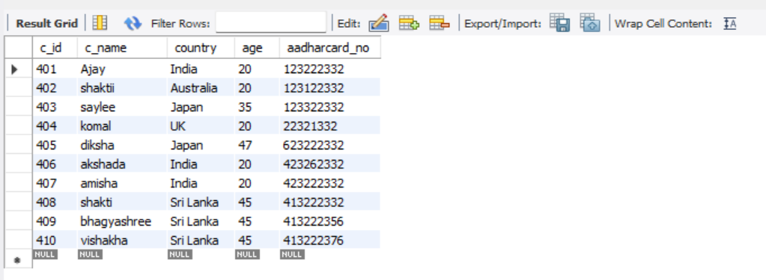

**-- 13)list down all the sales id,product id,product name and quantity**

select s.s_id,p.p_id,p.p_name,s.quantity

from sales as s inner join product as p

on s.p_id=p.p_id;

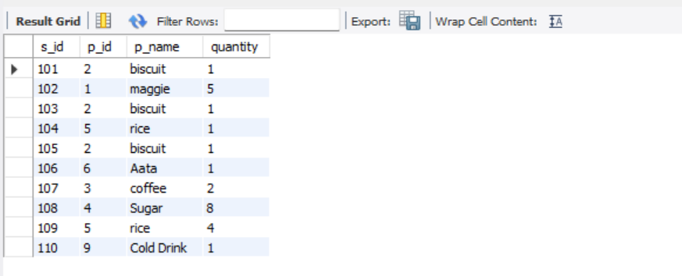

**-- 14)search for all the customer from "UK","japan"and "sri lanka"**

select * from customer where country in ("UK","japan","sri lanka");

